

**CDIO**

Database Design Document

**DTUDocu**

(Doc-v1.0)

**PROJECT CODE: CDIO_DIS**

**DOCUMENT CODE: PRO_Doc1.1**

**PROJECT TEAM: Team 7**

**MENTOR: Msc. Sanh Tran Kim**

**TEAM MEMBERS:**

Mai Thi Huong Tra

Nguyen Duy Uyen

Pham Duy Tung

Nguyen Quoc Huy

**Da Nang, March 05, 2024**

Contents

Project Information 4

Proposal Document 4

1. Introduction 6

1.1. Purpose 6

1.2. Goal 6

1.3. Scope 6

1.4. Definitions, Acronyms and Abbreviations 7

1.5. Documents referenced 7

2. Database Design 7

2.1. Table Overview 7

2.2. Table relationship Diagram 8

2.3. Table Details 8

2.3.1. Account: 8

2.3.2. Customer: 9

2.3.3. Catalog: 9

2.3.4. Menu: 9

2.3.5. Product: 9

2.3.6. Order: 10

2.3.7. Comment: 10

2.3.8. Contact: 10

# Project Information

|  |  |  |  |  |
| --- | --- | --- | --- | --- |
| **Project acronym** | CDIO | | | |
| **Project Tittle** | DTUDocu | | | |
| **Start Date** | 11/01/2024 | **End Date** | 14/03/2024 | |
| **Lead Institution** | International School, Duy Tan University | | | |
| **Project Mentor** | Sanh Tran Kim, Msc | | | |
| **Product Owner** | Mai Thi Huong Tra | | | |
| **Scrum Master**  **& contact details** | Mai Thi Huong Tra | | | |
| **Project Web**  **URL** |  | | | |
| **Development Team members** | **Name** | **Email** | | **Tel** |
| **1** | Nguyen Duy Uyen | uyendii2682003@gmail.com | | 0901961764 |
| **2** | Nguyen Quoc Huy | nguyenhuy020703@gmail.com | | 0393448246 |
| **3** | Pham Duy Tung | pdt.phamduytung@gmail.com | | 0979389132 |

# Proposal Document

|  |  |  |  |
| --- | --- | --- | --- |
| **Document Title** | Proposal Document | | |
| **Reporting Period** | 14/03/2024 | | |
| **Author(s)** | Nguyen Duy Uyen | |  |
| **Role** | Product Owner, Developer’s member | Member | Pham Duy Tung |
|  | Developer’s member | Member | Nguyen Quoc Huy |
|  | Scrum Master, Developer’s member | Member | Mai Thi Huong Tra |
| **Date** | March 05, 2024 | Filename | Proposal_v1.0 |
| **URL** |  | | |
| **Access** | Project and CMU Program | |  |

|  |  |  |  |
| --- | --- | --- | --- |
| Document History | | | |
| **Version** | **Date** | **Comments** | **Updater** |
| V1.0 | 05/03/2024 | Database Design Document | Pham Duy Tung |

**Document Approvals:** The following signatures are required for approval of this document.

|  |  |  |  |
| --- | --- | --- | --- |
| **Mentor** | Tran Kim Sanh |  | Date |
| **Product Owner** | Pham Duy Tung |  | Date |
| **Scrum Master** | Mai Thi Huong Tra |  | Date |
| **DEV Team’s Member** | Nguyen Quoc Huy  Nguyen Duy Uyen |  | Date |

# Introduction

## Purpose

Place information system’s database design document describes structure of database and file structure of system. Database Design document will introduce all attribute the System that will help developer and tester base on this design to implement and test

## Goal

To create database tables most accurate.

## Scope

* This Database Design Document provides the basic for “Clothes Website Using AI” Database design.
* It defines the database that will support the “Clothes Website Using AI” Data Model.
* It describes both logical and physical definition, non-functional issues and the database interfaces, storage aspects are defined in the physical database design sections.
* The table performance considerations requirements. The following topics are covered in this document:
* Assumptions and decisions on database design.
* Entity-mapping.
* Table column definitions.
* Primary, unique and foreign key definitions.
* Column and row level validation rules (check constraints).
* Rule for populating specific columns (sequences, derivations, demoralized (column)).
* Interfaces and dependencies with other components.
* Data access description.
* The database design for “Clothes Website Using AI” is composed of definitions for database objects derived by mapping entities to tables attributes to columns, unique identifiers to unique keys and relationship to foreign keys.
* During design, these initial definitions are enhanced to support the functionality described in the functional specification/ user stories and defined in the primary and supporting modules of the application high level design

## Definitions, Acronyms and Abbreviations

|  |  |  |
| --- | --- | --- |
| **Abbreviations** | **Description** | **Comment** |
| PK/FK | Primary/ Foreign Key | Use to indicate a file is a Primary or Foreign key in a table |
| ERD | Entity Relationship Diagram | Show the relationship between entities in the system |

## Documents referenced

|  |  |  |
| --- | --- | --- |
| **No.** | **References** | **Document information** |
| 1. |  |  |
| 1. |  |  |

# Database Design

## Table Overview

|  |  |  |
| --- | --- | --- |
| **No** | **Table name** | **Short Description** |
| 1 | User | Profile information of user |
| 2 | Login | Account information of user |
| 3 | storagefile | Information of file uploaded by user |

## Table relationship Diagram

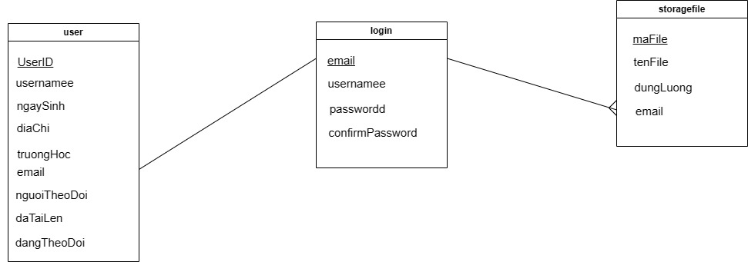

## Table Details

## User:

|  |  |  |  |  |  |
| --- | --- | --- | --- | --- | --- |
| Attributes | Data Type | Key | Null | Default | Description |
| UserID | Int(10) | PK | Not null |  | ID of user |
| usernamee | Varchar(50) |  | Not null |  | Name of user |
| ngaySinh | date |  | Not null |  | Date of birth |
| diaChi | Varchar(255) |  |  |  | Address of user |
| truongHoc | Varchar(255) |  |  |  | School of user |
| email | Varchar(50) |  |  |  | Email of user |
| nguoiTheoDoi | Int(11) |  |  |  | Followers of user |
| daTaiLen | Int(11) |  |  |  | File’s number of user |
| dangTheoDoi | Int(11) |  |  |  | User’s following of user |

## Login:

|  |  |  |  |  |  |
| --- | --- | --- | --- | --- | --- |
| Attributes | Data Type | Key | Null | Default | Description |
| email | Varchar(50) | PK | Not null |  | Email of User |
| usernamee | Varchar(50) |  | Not null |  | Name of user |
| passwordd | Varchar(50) |  | Not null |  | Password of User |
| confirmPassword | Varchar(50) |  |  |  | Confirm Password |

## Storagefile:

|  |  |  |  |  |  |
| --- | --- | --- | --- | --- | --- |
| Attributes | Data Type | Key | Null | Default | Description |
| maFile | int(11) | PK | Not null |  | ID of file |
| tenFile | Varchar(50) |  | Not null |  | Name of file |
| dungLuong | Varchar(50) |  |  |  | Size of file |
| email | Varchar(50) |  |  |  | Email of user |